*Keiretsu* and Economic Growth – Group 6

Contents

1. **Japan and its Keiretsu Ankit Pandey [17MF3FP18]**
   1. Timeline
   2. Keiretsu
   3. Keiretsu working culture
   4. Japanese Economy
2. **Analysis of Japanese Cases Ashish Gokarnkar [18IM30027]**
   1. Introduction
   2. Case Studies
   3. Generalization towards Japanese Economy
   4. Conclusion
3. **Stagnation of Japanese Economic Growth Adbul Ahadh [17AG3FP02]**
   1. Macroeconomic Performance, Policy & Planning
   2. Quality of Life
   3. The Collapse of the Japanese Economic Miracle

Japan and its *Keiretsu*

# Timeline

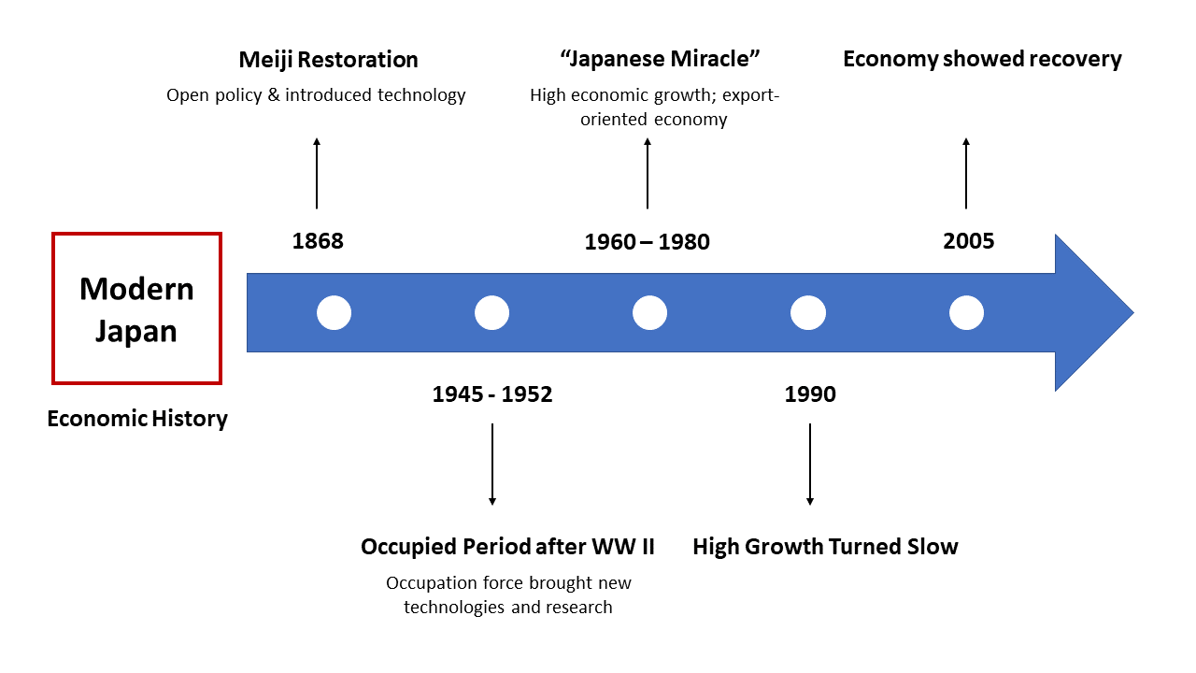

**Post 1600**

Confucian values were deeply absorbed by the educational system which had always emphasized loyalty to one’s immediate superiors and the respect for the nation state.

**1860s**

The earlier Samurais became salarymen and business heads. Therefore, they emphasized the Confucian values and the bushido samurai code in businesses. The principles of harmony along with loyalty was encouraged, leading to the rise of the family-based *Keiretsu* type groupism.

**1870s**

Meiji Restoration: The Japanese were wary of the rise of Europeans who had crumbled most of the major Asian empires. Seeing the rising need to adopt the Western technologies, Japanese students were sent to learn and bring these practices. This was when they saw the successful branches of the Rockefeller, Carnegie and Ford groups which shaped the present-day *Keiretsu*.

**1900s**

Japanese imperialism was on rise supported by the strong economic groups called *Zaibatsu*s (predecessors of *Keiretsu*). Captured Taiwan, Korea and Manchuria were used to test the economic models before using it in Japan, helping it to adopt better economic practices.

**1920s**

The four leading firm families, or *Zaibatsu*s: Mitsui, Mitsubishi, Sumitomo, and Yasuda, dominated the political and economic landscape. During World War II each of these were associated by a bank that provided them with a great stability and liquidity.

**Post 1960s till 1990**

After the world wars, *Zaibatsu*s were divided to break their hold on the Japanese economy and political landscape. But to contain the rising Communism in China, they were encouraged to rejoin, leading to the present day *Keiretsu*s. Yasuda took up a new name as Fuyo, the other 3 retained their names and two new *Keiretsu*s emerged, Sanwa and Ikkan. And this was ‘The Economic Miracle’, with their economy back to prewar levels with huge trade surpluses.

# Keiretsu

**Keiretsu** refers to a business network made up of different companies which maintain close relationships and encourage crossholdings of equity stakes while remaining operationally independent. There are 2 types:

* Horizontal keiretsu is an alliance of different companies centered around a bank.
* Vertical keiretsu refers to manufacturers and suppliers partnering to cut costs.

# Keiretsu Working Culture

The foundation of the Japanese economy is its highly educated and self-driven labor.

1. **Being worker-centric**, most of the quality improving innovations have been suggested by workers on site. The deeply embodied Confucian principles of loyalty and commitment to their respective firms are something that many other nations have tried to imbibe.
2. **Lifetime employment** is practiced, encouraging loyalty and draw forth innovative practices. Even though it is limited mostly to the workforce in large firms who must retire by the age of 55 with large severance payments, Japanese workers are generally more likely to stay with one company for a longer duration, even in small firms. This policy of long-term employment encourages firms to invest in the development of their workforce.
3. **Rotations**: To further dissuade employees from changing firms, these firms rotate the workers from job to job within the firm making them more firm-specific. Due to this, the employees know all about that firm but lack skills that are required in other firms. They are thus also more likely to get promotions in that firm rather than in other firms.
4. **Seniority wages** are awarded for the loyalty of being a lifetime employee and this practice is also consistent with the Confucian belief of showing respect for the seniors and elders. This is reflected by a steeper age-wage profile in Japan compared to others.
5. **Enterprise unions** are heavily backed by both the management and the labor. If one commits to lifetime employment and therefore has adapted himself to become a firm-specific worker, working at several different jobs with the firm, and thus not honing a particular skill to become a specialist in that department, then it is logical to form a union negotiating directly with that specific firm. These unions have both white and blue-collar employees and are therefore responsible for the smaller wage differentials.

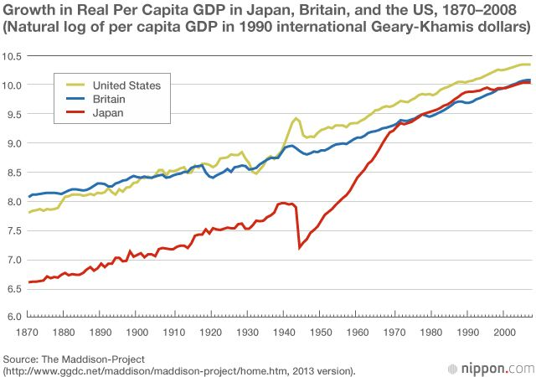 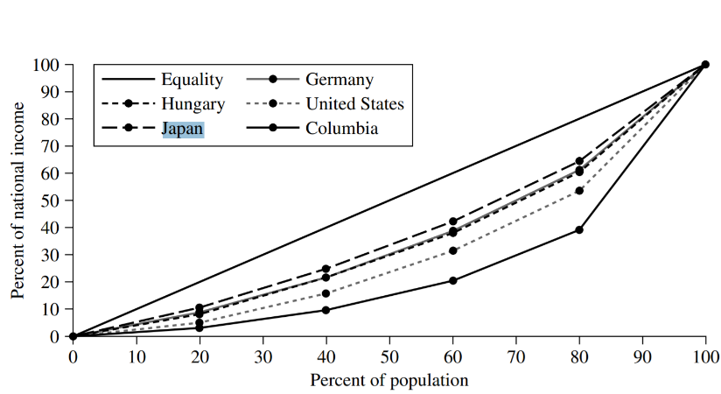

# Japanese Economy

* Having imbibed several of their neo-Confucian values, Japanese economy is also referred to as a New Traditional Economy. It has served as a model for several of the Asian economies.
* Economies vary based on the extent of government intervention to redistribute income in the economy. It also depends on how unequal income is, to begin with. Since Japan already has an equitable distribution, the government does much less redistributing.
* The west has a lesser concentrated economy than Japan because of the presence of strong antitrust enforcement. In Japan, even the firms that are officially independent have close relationships through the *keiretsu*s, making the economy more concentrated.
* In Japan, union membership is higher than in the United States, but labor-management relations have been more cooperative with one of the lowest strike rates.
* The state-owned firms of communist nations are less efficient as even if they lose money, they get bailed out. Comparing this to the *keiretsu* system, the groups of corporations are tightly linked to major banks that own large amounts of their stock and monitor their performance, imposing hard budget constraints, leading to higher efficiencies.

## Ability to focus on long term goals

1. Supported by a stable government of the LDP party which has been ruling since the 1950s except for 4-5 years, it has helped the bureaucrats to focus on long term goals.
2. Due to the presence of long-term employees and long-term relations with the banks, Japanese firms can focus on long term gains at the expense of low profitability. However, this low profitability plagued many Japanese firms during the 1990s.
3. Long-term bank financing helps to resist the stock market pressures like running for short term profits or the threats of a takeover. This is supported by the insulation provided by the crossholdings of stocks between banks and firms. Banks are more willing to agree for a long-term view as the Japanese savings rates are quite high, allowing low-interest rates which in turn trigger capital investment and a longer time horizon.

E.g. VCR technology was invented and initially produced by the US. However, the US producers voluntarily gave up VCRs because the market had a very slow growth rate which was not sustainable by the US firms leading to Japanese entry.

Analysis using Japanese Cases

# Introduction

The Meiji revolution in Japan (1603 – 1967) led to creation of various family centered businesses in Japan. These houses were referred to as *Zaibatsu*. Such *Zaibatsu*s had various verticals and business horizontals spanning in various industrial sectors with a high concentration in manufacturing. All underling companies of *Zaibatsu* had a web of shareholding created to safeguard Japanese economy from outside-world shocks and dislocations in the sectors of the economy they dominate. Scenario of *Zaibatsu*s evolved during the World War periods to further extend positions of Senior Managements outside the Major Shareholding Family. This further evolved to being called *Keiretsu*s with more bank-centered groups. Currently there exists 6 Enterprise Groups *(Big-6)* post-war. **Effect of affiliation with Big-6 on corporate financial performance for a given firm was positive in the early postwar-period (1950 – 1990), but negative thereafter.**

Keiretsu Structure

During distress *Keiretsu* deploy various tactics to mitigate losses and turnaround the bankrupt company. Firstly, **group firms do a substantial fraction of their borrowing from group financial institutions.** Main bank of the *Keiretsu* is one of these group financial institutions. Secondly, **key bank executives are placed in top managerial positions of the distressed firm.** Decisions are made to drive profits from other healthy firms to finance and assimilate the distressed firm’s cash flows.

# Case Studies (Source: The Japan Times Newspaper, *NKS archives 1980 - 1984*)

**Key case of restructuring is that of**  **by** . Mazda was under financial stress after first oil shocks due to inefficient management and decreased R&D spending which ultimately reduced its annual demand. In response, Sumitomo sent many of its top executives to serve as Mazda directors and manage key divisions of the company. Mazda was lent money at favorable rates and was encouraged to sell its shares in the bank. Entire Sumitomo *Keiretsu* switched their automobile purchases to Mazda and every group member was requested to create more scenarios and maximize purchase from Mazda. Suppliers were bargained to issue credit bills and not default on payments to Mazda. Mazda now is a profitable firm with consistent high growth. In *Keiretsu*s, whenever a member firm faces bankruptcy, combinations of financial support, pressure on suppliers, bank-induced managerial changes are deployed by the main banks to make miracles happen and turnaround the member firm from bankruptcy.

Examples of Interventions of Banks

|  |  |  |  |
| --- | --- | --- | --- |
| Name (domain) | *Keiretsu* Leader | Position assumed by executive sent by main bank | Assistance/ Restructuring measures taken by main bank |
| (audio equipment) | Mitsubishi Logo 1024*307 transprent Png Free Download - Text, Logo,  Mitsubishi Motors. - CleanPNG / KissPNG | President, Director | * Asset disposal * Internal rationalization * Tie-up with Mitsubishi Electric |
| Sanrio Puroland (pulp/ paper) | Sumitomo Logo - LogoDix | Vice President, Director | * Large-scale asset disposal focused on real-estate and equity * Labor-force reductions (1000) * Reduced debt by ¥ 260 B |
| Nihon Yakin  (stainless steel) | Industrial Bank of Japan - Wikipedia | President, Auditor – Director, Senior Managing Director | * Internal cost cutting and organizational streamlining * Interest reductions * Tie-ups with Nippon Steel Corporation and Showa Denko * Spin-off of smelter (profit - ¥ 5.2 B) |
| Hakodate Dockyard  (shipbuilding) | The Company | President | * Arranging takeover by Kurujima Dockyard * Shelving interest payments * Internal cost cutting and labor-force reductions (1100) |
| Ataka & Co.  (General Trading Company) | Sumitomo Logo - LogoDix | Top Advisor, 12 assistants, President | * Wrote off ¥ 113.2 B * Split into 2 parts   + First part taken over by Ito Chu   + Second part taken over by Sumitomo Bank absorbing losses of ¥ 497 B |
| Search by Company | Archives | MExpress JAPAN : Search Engine for Japanese  Exhibits | News Digest Publishing (Machinery Trading Company) | Daiwa Logos | Senior Executive Managing Directors | * Borrowings of ¥ 23 B * Real estate and apartment-house division transferred to wholly owned subsidiary |

Examples of Bank Assistance for Struggling Firms

|  |  |  |
| --- | --- | --- |
| Name | *Keiretsu* Bank | Measures Undertaken |
|  |  | Conversion of long-term borrowings as per short term rate to series of short-term borrowing |
| Daisue Construction - Crunchbase Company Profile & FundingConstruction |  | * Loans written off as bad debts * Interest reductions and shelved (¥ 35 B) * Land investments transferred to subsidiary |
| Kojin (Textiles) | Dai-Ichi Kangyo Bank - The Reader Wiki, Reader View of Wikipedia | Interests payments shelved |
| Nitto Tires | Dino's Tire & Wheel | 918-838-3807(tyres) | Mitsubishi Logo 1024*307 transprent Png Free Download - Text, Logo,  Mitsubishi Motors. - CleanPNG / KissPNG | Interest rate on loan repayments exempted |

# Generalization towards entire Japanese Economy

To summarize the above case studies and present a conclusion to the impact on Japanese Corporate Performance by *Keiretsu* Networks, a literature review from “Keiretsu Networks and Corporate Performance [Lincoln and Gerlach, 1996] has been presented. The following study is based on the study of profitability of firm integration in Big-6 Keiretsu networks for 197 large Japanese firms over a 24-year period. In a nutshell, ***Keiretsu* group affiliation and prior performance are negatively proportional to each other, constrained on the prior performance being lagged for a specific time interval (for intervention to occur and its total corporate impact to become clear).**

**For distressed firms, dependence on a group yields real benefits: Bankruptcy risk is attenuated, normal operation (e.g., ongoing investment) continues and recovery accelerates. But this comes at a heavy cost to the group, and particularly its leaders (the main bank, major customers, strong performers). In long run, the successful rescue and turnaround of a business partner may pay for itself, for e.g., in loans and contracts otherwise lost to failure, but in the short-term rescue team may face severe burden.**

To measure the impact of *Keiretsu* affiliation, linear regression on ROA of firms at multiple time instances has been used as defining variables. The equation gather is presented as:

$$ROA_{it}=α+βx_{it}+γROA_{it-k}+δG_{it}+λG_{it}*ROA_{it-k}+ϵ_{it}$$

Variables are defined to differentiate performance of *Keiretsu* firms to independent firms

* $ROA_{it-k}$– Return on Assets lagged by $k$ years
* $ϵ_{it}$– Stochastic Error
* $δ$– Difference in intercepts
* $λ$– Differentiator between group and non-group firms in $ROA_{it}$ on $ROA_{it-k}$ slopes
* $β$ is the slope of regression model
* $α$ is the drift in the model
* $x_{it}$– vector of control variables for firm $i$ at time $t$
  + Age of company
  + D/E ratio
  + Dummy variables to simulate shocks
  + % growth in sales
  + Total assets
  + Ties of Affiliation – *Sacho-kai* membership

Dataset: NEEDS Tape by Nikkei Databank Bureau for top **197 industrial firms** in terms of company sales over the period from 1965 to 1988. Top 10 shareholders, leading lenders with loan amounts of each industrial firm and amount of their shareholdings were coded from *Keiretsu no Kangyo* excerpts. *Kaisha nenkan* was used to gather additional financial information on each firm regarding Trading ties (names of suppliers and clients). *Shacho-kai* membership was coded from Japanese Industrial Groupings.

Analysis: Japanese corporations with ties to Big-6 horizontal *Keiretsu*s are less profitable than unaffiliated firms but are more likely to recover from financial shocks. *Keiretsu* networks operate in a profitability – financial security tradeoff. It has been often cited that firms with affiliations to Big-6 are perform weaker financially with very high constraints on profitability, hence, as of the current Japanese economy, *Keiretsu* firms are breaking down in financial dimensions. The Japanese corporate bond market and acceleration in deregulation of Tokyo Stock Exchange have made it easier for firms to scout investment opportunities without relying on *Keiretsu* network’sbanks and insurance companies. After the boom of startup ecosystem, the younger, nimble, and aggressive job shops and startups are the leading edge of modern Japanese economy. Keiretsus have very few attractions for these small firms.

*Keiretsu*s follow a redistributive process, whereby *Keiretsu* groups penalize healthy firms to subsidize performance of weaker firms or to enforce group norms which restrict rates of return to imply profit homogeneity throughout the network. Resources are distributed among group members in such a way with vision of long-term collectivistic welfare. It creates a fall back web for the weaker performing members, as *Keiretsu*s monitor profiteering by creating group wide norms to redirect profits from high performing firms to these weaker firms. It insulates its entire corporate web from harsh scrutiny of tax authorities and investment analysts by managing the reporting of profits and losses to show steady, incremental growth. Economic role of *Keiretsu* networks is of collectivistic action to maximize joint welfare of the member firms by controlling both risks borne and redistribution of returns by individual firms and moderating group-administered allocation plan.

On dimensions of Big-6 affiliation, **group and independent firms differ only at the extremes of R $OA_{it-k}$** (e.g., below 0% and above 20%). Apart from these thresholds there exists very little evidence that group ties make a difference.

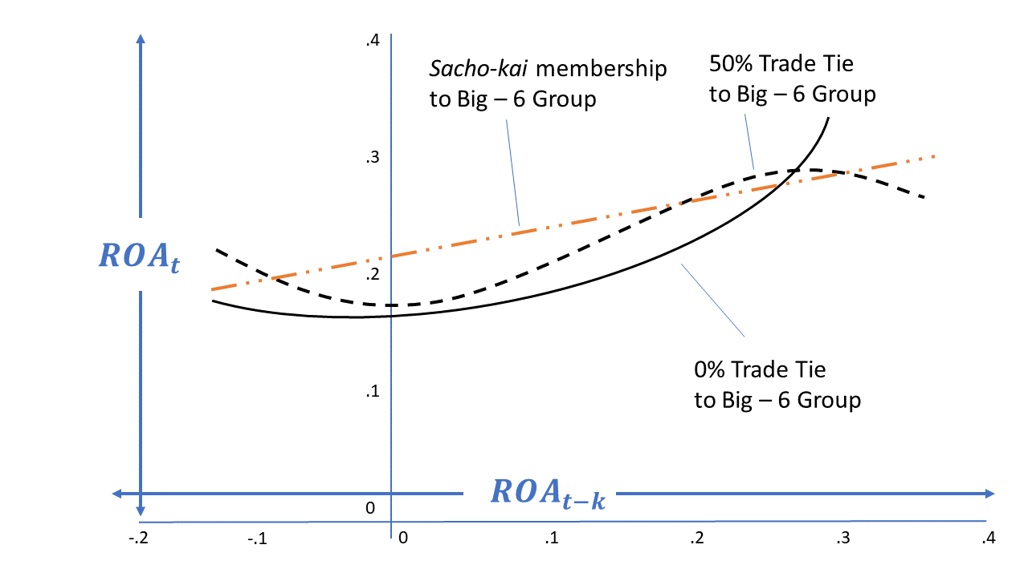

For firms with low ROA at time $t-k$ (e.g., near-zero or negative profitability), Big-6 affiliation is a net plus. For firms beyond these zero thresholds, *Keiretsu* membership generally lowers subsequent performance.

*Keiretsu* are prone to be very detrimental to performance of continuously high profiting member firms. To why these firms still retain their membership are taken in a psychological feature of Japanese anthropology – Japanese people are risk-averse. Hence, they prefer to hedge today’s profits for balancing future chances of failure. Plus, being in a *Keiretsu* opens them up for many internal business relations across suppliers and clientele. Group firms are 3x more likely to trade with group members than non-group members. To accommodate the modern economic interests of members, *Keiretsu*s have evolved a little to allow members to create their own course with limited freedom and pick alliances based on self-interest to some degree. But nonetheless, *Keiretsu*s logic has been engraved in the Japanese mentality since the primitive eras and thus it doesn’t seem that they’ll be eradicated nor reduced to a particular firm’s rational optimizing.

Conclusion: ***Keiretsu*s are a core concept of Japanese culture and its output in economy is very similar to that of non-enterprise grouping economies like that of America and Europe. They are very beneficial to large firms (e.g. manufacturing and retail groups) (firms with medium range % growth and which operate in instable markets) and allow them a sense of security and belonging to make bold decisions freeing them from thoughts of bankruptcy. Small/ high-profiting firms don’t opt for *Keiretsu* memberships but they still fare comparable to *Keiretsu* firms. *Keiretsu*s were very profitable and economically impactful right after post-war period but now they show indifferent performance.**

Stagnation of Japan’s Economic Growth

# Macroeconomic Performance, Policy & Planning:

|  |  |  |  |  |
| --- | --- | --- | --- | --- |
| Years | Japan | France | Germany | USA |
| 1966 – 1973 | 10.1 | 5.8 | 4.3 | 3.6 |
| 1973 – 1980 | 4.3 | 2.9 | 2.6 | 2.9 |
| 1980 – 1990 | 3.8 | 1.1 | 1.4 | 1.4 |
| 1990 – 1999 | 1.4 | 1.7 | 1.5 | 3.4 |

**1880 - 1940 →** Average annual growth of real GDP was 3.41%, which was higher than that of any leading market capitalist economies at that time

**1945 - 1990 →** Japan had the highest economic growth (as seen in the above figure) that too while maintaining a mere 1-2.5% unemployment rate. This growth figure was backed by a high savings rate which fed to a high capital investment rate.

**Post 1990 →** Japanese stock market bubble burst which pushed their growth rates below leading market capitalist economies, adding to it the unemployment rate rose above 5% by 2002. The savings rate remained high in Japan and so has the investment rate been.

The surplus income accumulated by the high growth rates were used to make down payments on abnormally overpriced homes at that period. Japan had a young population during the post-war period and large biannual bonuses combined with early retirements with low social security

payments and low pensions encouraged the young workers (major chunk of the population) to save for old age. But this is leading to a rapidly aging population which implies a rising dependency ratio which further lead to a depressed savings rate when combined with Japan’s falling birth rate and early retirement.

The Economic Planning Agency (EPA) puts forth Japan’s macroeconomic plans with policy goals while MOF implements them. While the plan exceedingly worked out well for them till the ‘70s, the reverse was the case in the period ‘70-’83. MOF was not only in-charge of the Government's budget and fiscal policy, but lately they were also in charge of the central bank. The fiscal policy structures laid out attracted much attention because of the relatively low government spending and taxation. Budget Deficits surged to 7% of the GDP by 1998 and the national debt to GDP ratio reached 150% by early 2002. The stimulative fiscal policy laid out and monetary policy having 0% overnight interbank rates failed to convert a high economic growth rate.

# Quality of Life

Japan was still ahead of leading economies in terms of per-capita income and per capita consumption, while the effect of this was hampered down when considering the purchasing power parity (PPP) because of its high cost of food and housing relatively as shown in figure below.

Another interesting metric on the quality of life is the crime rate which was low in Japan during the ‘90s while other countries had a relatively high crime rate. This rate has been on the rise in Japan while still remaining less when compared to the same countries. Also, the labor management system in Japan has garnered a more equal income distribution when compared to the leading market capitalist economies.

The darker side of the highly motivated Japanese work culture is captured by the much longer hours with less vacations than any other country. Cities are highly congested, and the people spend long hours commuting. Last but not the least, Japanese society suffers a great deal from discrimination: starting from lesser wages received by women than men till discrimination against foreigners (mostly Koreans) who are restricted in their personal and professional activities.

Selected Gini Coefficients:

|  |  |  |  |  |  |
| --- | --- | --- | --- | --- | --- |
| Mid 1970s | Japan | Sweden | West Germany | USA | OECD Average |
| Before Taxes | 0.335 | 0.346 | 0.396 | 0.404 | 0.366 |
| After Taxes | 0.316 | 0.302 | 0.33 | 0.381 | 0.350 |
| Mid 1990s, after Taxes | 0.249 | 0.250 | 0.300 | 0.408 | N.A. |

# The Collapse of the Japanese Economic Miracle:

The enormous hype of Japan’s long-term prospects in the 1980s ran out of steam by the 1990s. This altered situation can be explained by the factors mentioned below (may or may not be mutually exclusive causes as some economists argue):

* Decrease in savings because of increase in dependency ratios
* Weakness of non-tradable goods industry in a dual economy
* Opening of financial markets caused by deregulation
* Leakage of capital via large corporations’ investments in other countries
* Decrease in the consumers’ tax cut spending because of the fear of job loss
* Decrease in the rate of return to capital investment owing to overinvestment in the past
* Accumulation of bad loans in the banking sector
* Arguably, decline in the work ethics among the younger generation and the breakdown of their Confucian values

Economists argue that these factors varied in significance throughout the 1990s. Some call out for the end to the role of banks as the center to the *Keiretsu*s.**Some call out the *Keiretsu* system itself.**

# References

## Analysis of Japanese Cases

Lincoln, James R., et al. “**Keiretsu Networks and Corporate Performance in Japan.**” *American Sociological Review*, vol. 61, no. 1, 1996, pp. 67–88. *JSTOR*, [www.jstor.org/stable/2096407](http://www.jstor.org/stable/2096407.)

Pascale, Richard, and Thomas P. Rohlen. “**The Mazda Turnaround.**” *Journal of Japanese Studies*, vol. 9, no. 2, 1983, pp. 219–263. *JSTOR*, [www.jstor.org/stable/132293](http://www.jstor.org/stable/132293)

Takeo Hoshi, Anil Kashyap, David Scharfstein, “**The role of banks in reducing the costs of financial distress in Japan**”, *Journal of Financial Economics*, Volume 27, Issue 1, 1990, Pages 67-88, ISSN 0304-405X, <https://doi.org/10.1016/0304-405X(90)90021-Q>

Paul Sheard, “**The main bank system and corporate monitoring and control in Japan**”, *Journal of Economic Behavior & Organization*, Volume 11, Issue 3, 1989, Pages 399-422, ISSN 0167-2681, <https://doi.org/10.1016/0167-2681(89)90037-1>

## Stagnation of Japan’s Economic Growth

Understanding the Japanese Economy (Research Exercises for Students) <http://afe.easia.columbia.edu/special/japan_1950_economy_research.htm>

Country comparison Japan vs India <https://countryeconomy.com/countries/compare/japan/india>

End of Report. © Academic License v3.0